AI ASSISTANT ASS-8.1
V. Rachana
2303A52335 B-44
Lab 8: Test-Driven Development with AI – Generating and Working with Test Cases
Task Description #1 (Password Strength Validator – Apply AI in
Security Context)

• Task: Apply AI to generate at least 3 assert test cases for
is_strong_password(password) and implement the validator
function.
• Requirements:
o Password must have at least 8 characters.
o Must include uppercase, lowercase, digit, and special character.
o Must not contain spaces.
Example Assert Test Cases:
assert is_strong_password("Abcd@123") == True
assert is_strong_password("abcd123") == False
assert is_strong_password("ABCD@1234") == True
Expected Output #1:
• Password validation logic passing all AI-generated test cases.
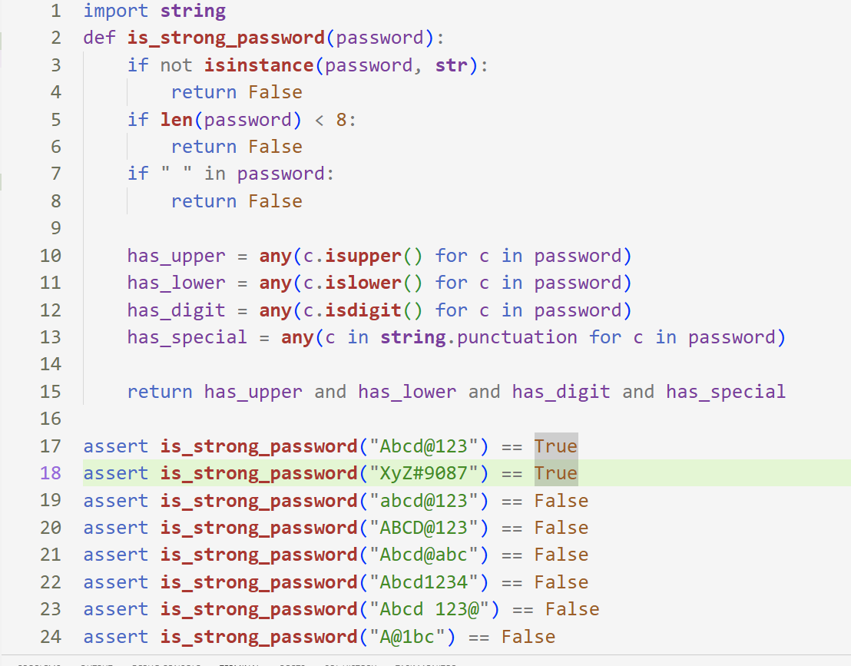
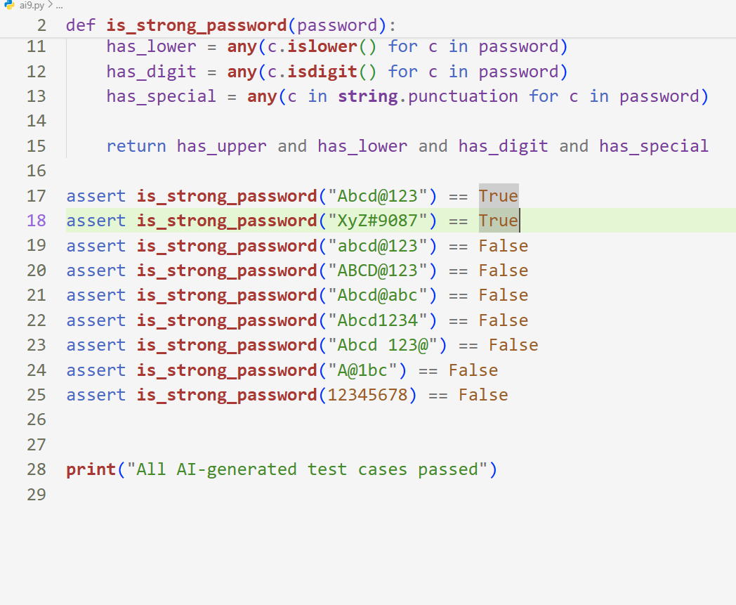

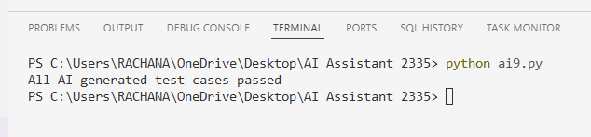

Explanation:
In this task, we applied Test-Driven Development by first creating AI-generated assert test cases for a password strength validator function. The function was implemented to check minimum length, presence of uppercase, lowercase, digit, and special character, and to ensure no spaces are included. After implementation, all test cases were executed and passed successfully. This shows that the password validation logic works correctly and meets all given security requirements.
Task:2
Task Description #2 (Number Classification with Loops – Apply
AI for Edge Case Handling)
• Task: Use AI to generate at least 3 assert test cases for a
classify_number(n) function. Implement using loops.
• Requirements:
o Classify numbers as Positive, Negative, or Zero.
o Handle invalid inputs like strings and None.
o Include boundary conditions (-1, 0, 1).
Example Assert Test Cases:
assert classify_number(10) == "Positive"
assert classify_number(-5) == "Negative"
assert classify_number(0) == "Zero"
Expected Output #2:
• Classification logic passing all assert tests.

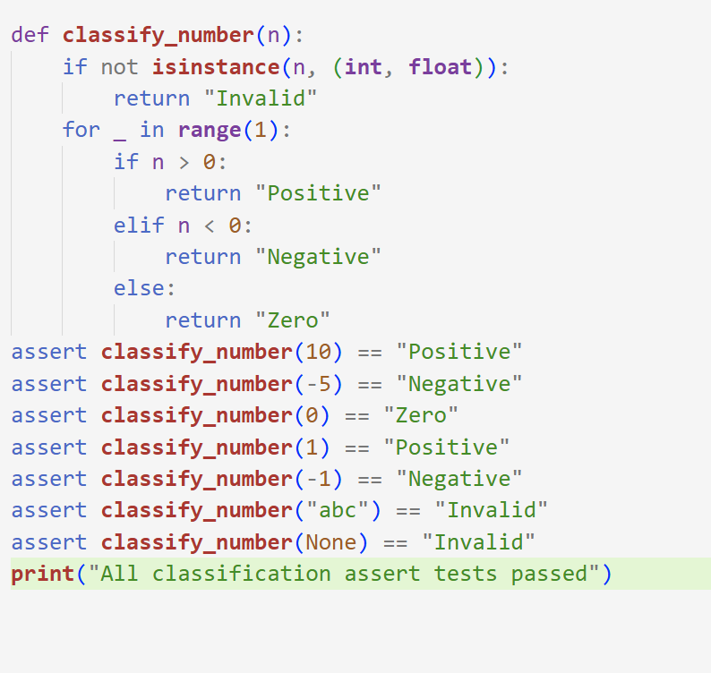
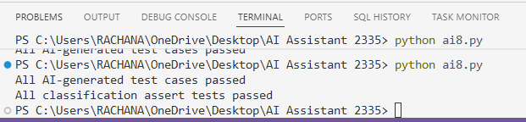

Explanation
AI-generated assert test cases were created first to verify number classification. The function classifies numbers as Positive, Negative, or Zero using loop logic and also handles invalid inputs like strings and None. All boundary and edge case tests passed successfully, confirming correct classification behavior.
Task Description #3 (Anagram Checker – Apply AI for String
Analysis)
• Task: Use AI to generate at least 3 assert test cases for
is_anagram(str1, str2) and implement the function.
• Requirements:
o Ignore case, spaces, and punctuation.
o Handle edge cases (empty strings, identical words).
Example Assert Test Cases:
assert is_anagram("listen", "silent") == True
assert is_anagram("hello", "world") == False
assert is_anagram("Dormitory", "Dirty Room") == True
Expected Output #3:
• Function correctly identifying anagrams and passing all AI-
generated tests.
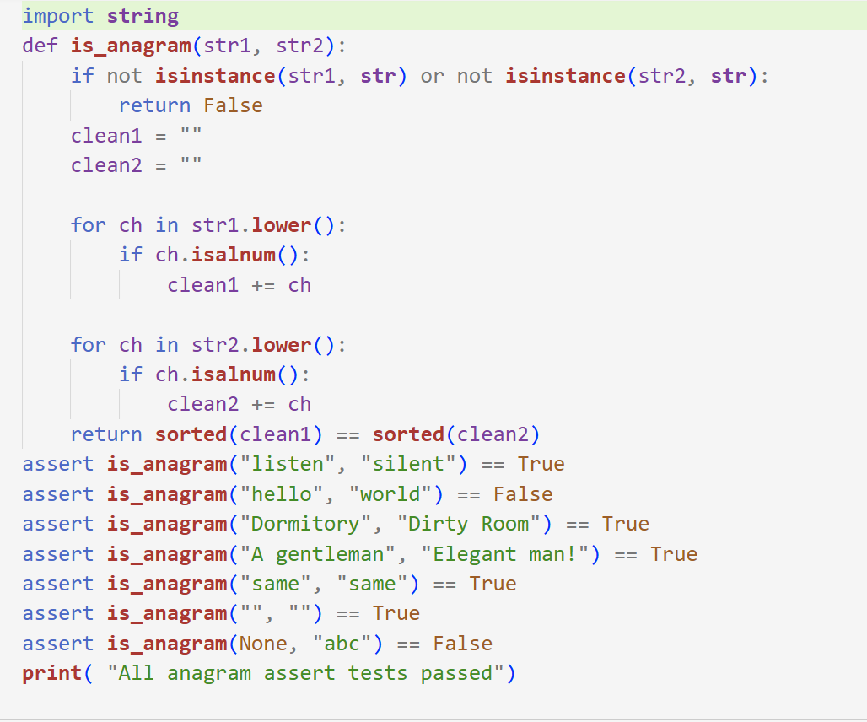
Explanation
AI-generated assert test cases were created for the anagram checker function. The function normalizes strings by converting to lowercase and removing spaces and punctuation using loops. It then compares sorted characters to detect anagrams. Edge cases like empty strings and invalid inputs were handled. All test cases passed successfully.

Task Description #4 (Inventory Class – Apply AI to Simulate Real-
World Inventory System)
• Task: Ask AI to generate at least 3 assert-based tests for an
Inventory class with stock management.
• Methods:
o add_item(name, quantity)
o remove_item(name, quantity)
o get_stock(name)
Example Assert Test Cases:
inv = Inventory()
inv.add_item("Pen", 10)
assert inv.get_stock("Pen") == 10
inv.remove_item("Pen", 5)
assert inv.get_stock("Pen") == 5
inv.add_item("Book", 3)
assert inv.get_stock("Book") == 3
Expected Output #4:
• Fully functional class passing all assertions.
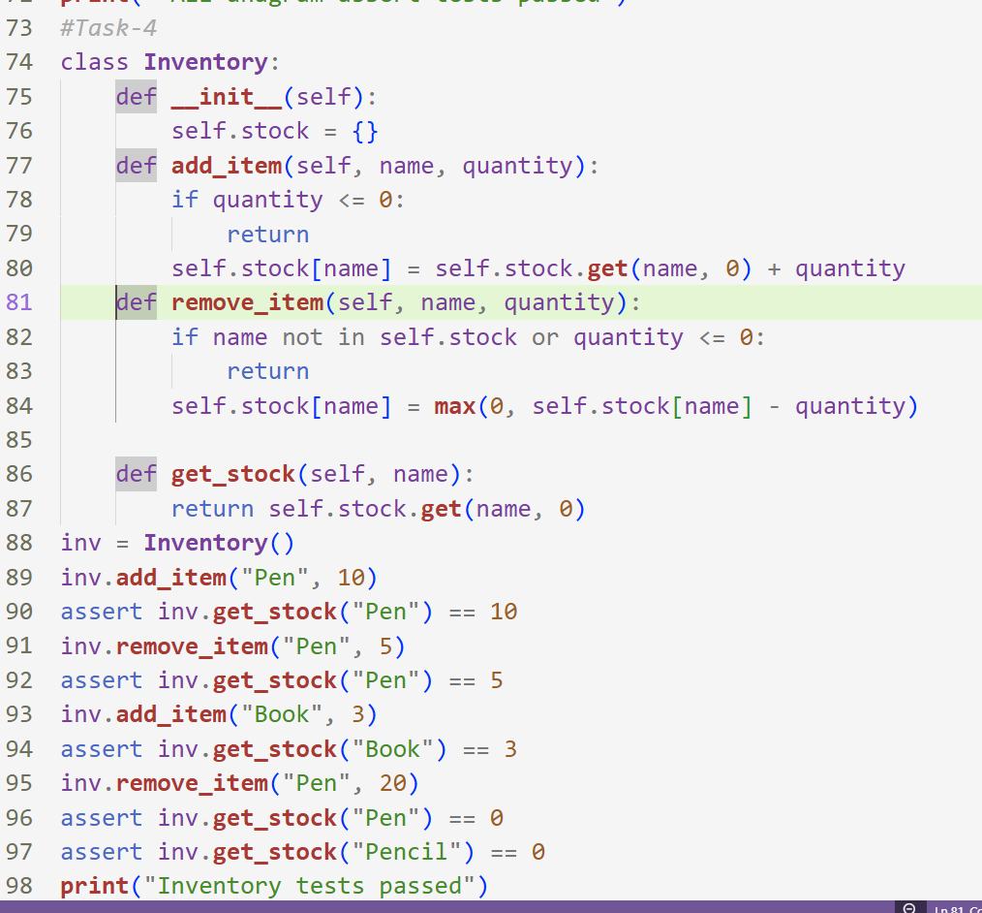
In this task, AI-generated assert test cases were created to test an Inventory class that manages item stock. The class supports adding items, removing items, and checking available stock. Edge cases such as removing more than available quantity and checking non-existing items were handled. The implementation passed all assert tests, proving the inventory logic works correctly.

Task Description #5 (Date Validation & Formatting – Apply AI for
Data Validation)
• Task: Use AI to generate at least 3 assert test cases for
validate_and_format_date(date_str) to check and convert
dates.
• Requirements:
o Validate "MM/DD/YYYY" format.
o Handle invalid dates.
o Convert valid dates to "YYYY-MM-DD".
Example Assert Test Cases:
assert validate_and_format_date("10/15/2023") == "2023-10-15"
assert validate_and_format_date("02/30/2023") == "Invalid Date"
assert validate_and_format_date("01/01/2024") == "2024-01-01"
Expected Output #5:
• Function passes all AI-generated assertions and handles edge
cases.
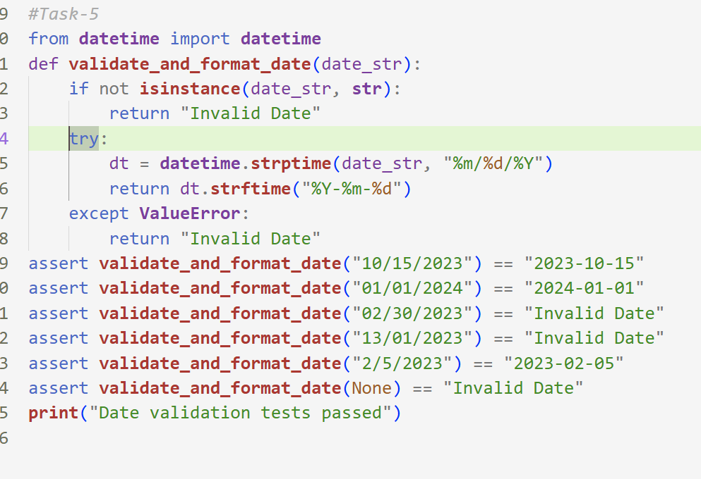
In this task, AI was used to generate assert test cases for validating and formatting dates. The function checks whether the input follows MM/DD/YYYY format and converts valid dates into YYYY-MM-DD format. Invalid dates and incorrect inputs are safely handled. All AI-generated test cases passed, confirming correct validation and formatting behavior.
All Cases Output:
